ChemE 486

Planning Report

Tora Gao, Shi Zheng, Leon Zhang

## Abstract

Ammonia is an important chemical mainly used in the food and agricultural industry. It is used as a fertilizer to support half of the world’s population. However, ammonia also accounts for 1-3% of the world’s energy consumption, 5% of natural gas consumption, and 3% of greenhouse gas emissions. Traditionally, in the US, ammonia is manufactured along the Gulf Coast region because of the cheap natural gas, and then transferred to the “corn belt” in the Midwest region by truck or rail. Since Ammonia is toxic at ambient condition, shipping is expensive. As a result, in this project, we are asked to design a modular ammonia synthesis process which allows for small-scale ammonia synthesis and is economically feasible in a long-term view. The modular plant we design can produce 10 metric tons of commercial-grade anhydrous ammonia (with a mass purity of 99.5%) per day. To meet the project requirement of 50 metric tons per day (mtpd), a combination of five units at a scale of 10 mtpd will be needed.

The upstream process of the ammonia synthesis consists of hydrogen gas production and nitrogen gas production. Considering the abundant wind energy available along the “corn belt”, we decide to use electrolysis of water to produce hydrogen. During this process, water is first purified through a purifying unit, then mixed with a highly conductive electrolyte (i.e. KOH, typically 20% to 30% of total solution) before being sent to the electrolyzer unit.1 After the electrolysis is complete, the oxygen gas will be separated from the hydrogen gas. A potential option is to sell the high-purity oxygen. Hydrogen, on the other hand, will be prepared to react with nitrogen to form ammonia. To produce nitrogen gas, we decided to use Pressure Swing Absorption (PSA). In this process, air is first purified, by separating any contaminants and water vapor, before being sent to the PSA unit. The PSA unit separates nitrogen gas from the rest of the gases and the gas is then prepared for its upcoming reaction with the hydrogen from the electrolysis unit.2

The downstream process reacts hydrogen gas and nitrogen gas to form ammonia. Because of the nature of high energy and capital cost associated with the traditional Haber-Bosch method, we decided to use absorbent-enhanced ammonia synthesis for this process. Essentially, it uses a bed of supported alkali metal salt to replace the conventional condenser in an ammonia synthesis loop. This allows the temperature, and more importantly, pressure of the process to be significantly reduced; hence, allowing the Haber-Bosch process to be scaled-down effectively. In this process, hydrogen and nitrogen gas react on a fix bed and cooled before being sent to the absorption column. Inside of the absorption column, magnesium chloride is used as the absorbent to separate ammonia from the unreacted reactants. Once the absorber is saturated, it is then desorbed to release the ammonia product. From there, we can pressurize the ammonia into the liquid phase for storage.3 Moreover, a recycle stream from the absorption column (consisting of unreacted nitrogen, hydrogen, and non-desorbed ammonia) is sent back to the reactor to be combined with fresh feed to improve the overall conversion.

## Block Flow Diagram

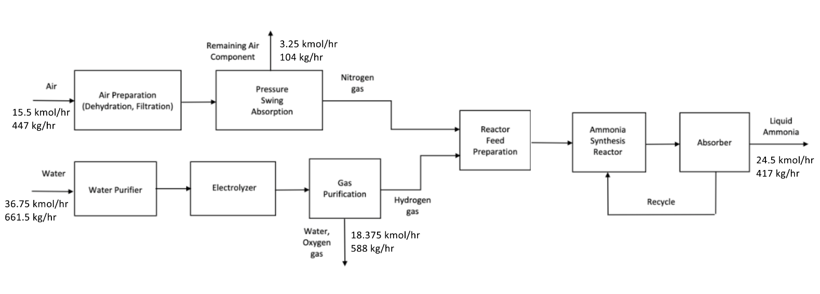

The mass balance assumes:

* Complete separation of product in the absorber
* Stoichiometric ratio of reactant fed into reactor
* 100% pure N2/H2 produced from upstream processes
* Composition of air is 79% N2 and 21% O2

Additionally, this diagram is at a unit scale of 10 mtpd production of ammonia (24.5 kmol/hr of ammonia is equal to 10 mtpd). We will use a numbering-up approach through parallel modular manufacturing to meet the 50 mtpd requirement. It should also be noted that this process is a cyclic continuous process and will operate with two absorption columns to maintain continuous operation.

## Initial Kinetics Data

$H_{2}$ and $N_{2}$ production are physical processes (electrolysis and pressure swing absorption), and there is no reaction involved. Therefore, we provided an estimate of conversion/selectivity (which we both assume to be 100%) instead of kinetics data.

The reaction mechanism regarding Haber-Bosch ammonia production is well known to be:

$$N_{2}\left(g\right)+{3H}_{2}\left(g\right)⇌3NH_{3}(g)$$

The rate law, in Langmuir-Hinshelwood-Haougen-Watson (LHHW) form, can be modeled as follows:4

[4]

where

$K_{1}= k_{o1}e^{-E_{1}/RT}$ with $k_{o1}=1.78954×{10}^{4} \frac{kgmol}{m^{3}∙hr∙{atm}^{1.5}}$ and $E_{1}=20800 kcal/kgmol$ [4]

$K_{2}= k_{o2}e^{-E_{2}/RT}$ with $k_{o1}=2.5714×{10}^{16} \frac{kgmol∙{atm}^{0.5}}{m^{3}∙hr}$ and $E_{1}=47400 kcal/kgmol$ [4]

Assume $K_{3}$ = 2 ${atm}^{-1}$

Pi corresponds to the partial pressure of component i.

## Thermodynamics Package

The thermodynamic package we have decided to use is the Peng Robinson equation of state because it works well with gaseous and non-polar components, which align with our process well. Moreover, Peng Robinson method provides good accuracy for all kinds of fluid properties.

An alternative option is Soave-Redlich-Kong (SRK), which has a similar performance as Peng Robinson but more specialized in predicting gas-phase properties. Most of our streams are in the in gaseous state except for the final absorption of ammonia, which is in liquid phase. Therefore, the SRK method is also a viable option.

## Cost Estimate

Assume that air does not cost anything because we can source it from the atmosphere.

Deionized (DI) water costs $1/1000 kg.5

Anhydrous ammonia can be estimated to be sold at $512/ton.6

Assume a stream factor of 0.95.

$$DI water cost= 5 modular units*\frac{661.5 kg}{hr*modular unit}*\frac{24 hr}{day}*\frac{365 days}{year}*0.95*\frac{\$1}{1000 kg}=\frac{\$27,525}{year}$$

$$Anhydrous ammonia profit=5 modular units*\frac{417 kg}{hr*modular unit}*\frac{24 hr}{day}*\frac{365 days}{year}*0.95*\frac{1 ton}{907.185 kg}*\frac{\$512}{ton}=\frac{\$9,792,822}{year}$$

Annual profit estimate based on raw material cost and product profit:

$$Annual profit= \frac{\$9,792,822}{year}-\frac{\$27,525}{year}=\frac{\$9,765,297}{year}$$

## References

[1] Keçebaş, A., Kayfeci, M., & Bayat, M. (2019). *Solar Hydrogen Production: processes, systems and technologies*. S.l.: ELSEVIER ACADEMIC PRESS. doi: 10.1016/B978-0-12-814853-2.00009-6

[2] Ivy, J., 2004. [online] Nrel.gov. Available at: <https://www.nrel.gov/docs/fy04osti/36734.pdf> [Accessed 13 April 2020].

[3] Palys, M., Mccormick, A., Cussler, E., & Daoutidis, P. (2018). Modeling and Optimal Design of Absorbent Enhanced Ammonia Synthesis. *Processes*, *6*(7), 91. doi: 10.3390/pr6070091

[4] Murase, A., Roberts, H. L., & Converse, A. O. (1970). Optimal Thermal Design of an Autothermal Ammonia Synthesis Reactor. *Industrial & Engineering Chemistry Process Design and Development*, *9*(4), 503–513. doi: 10.1021/i260036a003

[5] Turton, Richard, et al. Analysis, Synthesis, and Design of Chemical Processes. 4th ed., Pearson Education International, 2012.

[6] Schnitkey, G., Consumer Economics, & University of Illinois. (2018, September 26). Fertilizer Prices Higher for 2019 Crop • farmdoc daily. Retrieved April 13, 2020, from https://farmdocdaily.illinois.edu/2018/09/fertilizer-prices-higher-for-2019-crop.html